**ASAPIO - How To Get Started Guide**

**Checklist**

These are the steps you need to do to get the SAP system set up for the workshop.

* Installed the framework transport (ERDK904462)
* Installed the Solace connector package (ERDK904501)
* Activated BC-Set
* Installed the preconfigured content (ERDK904593)
* Added necessary roles to WF-BATCH / SAP_WFRT
* Adapted the RFC Destination

Follow the steps below to complete the checklist.

**Base Configuration**

Download and import into your SAP system from here:

https://asapio.freshdesk.com/discussions/topics/14000020247

1. Framework (Only if this is your first connector): (ERDK904462)
2. Connector to Solace: (ERDK904501)

Import configuration

1. Activate BC-Set:

* Transaction: SCPR20
* BC-Set: /ASADEV/ACI_BCSET_FRAMEWORK_AEM.
* Activate with default settings

1. Additional transport with preconfigured content: (ERDK904593) https://asapio.freshdesk,com/support/discussions/forums/14000131371

Add Roles and Authorizations to your SAP User and SAP Workflow User.

1. At least one SAP-User will need the administrator role touse the ASAPIO Monitor

etc.: /ASADEV/ACI_ADMIN_ROLE

1. Technical / system user like“WF-BATCH”or“SAP_WFRT”will need role:

/ASADEV/ACI_JOB_ROLE

https://asapio.com/docs/installation/#roles_and_authorizations

Note: If you don’t know your technical system user then go to transaction SWU3 --> Maintain Runtime Environment --> Configure RFC Destination. This needs to be generated and on the right side it will show you the technical system user.

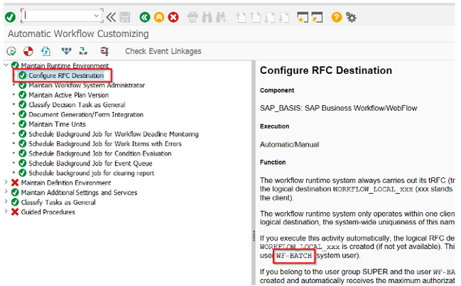

7. Create RFC destinations

Create a new RFC destination of type “G” (HTTP Connection to External Server) i Transaction: SM59

Specify Target Host and Service No. (Port): endpoint for the SAP Advanced Event

mesh

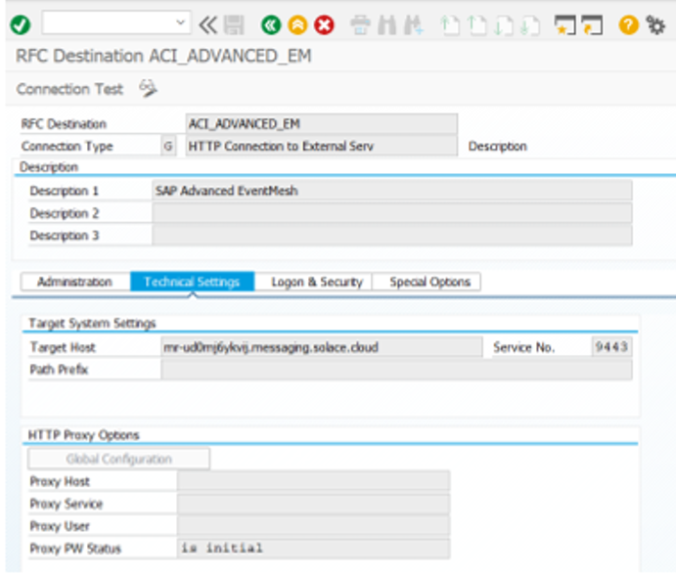

- Credentials or certificates for authentication can be specified on tab Logon & Security:

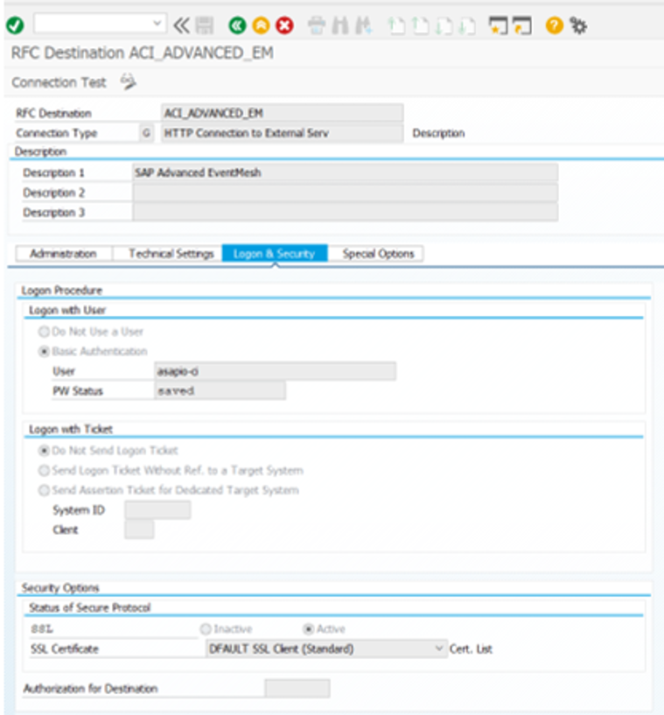

When activating SSL please ensure that the necessary certificates are in the selected Certificate List (keystore) in your SAP system. To get the necessary certificates for the https/SSL connection you can follow the next section to download them via your browser. Browser specific way toget a certificate.

Note: This is just one option to get a certificate. Open your endpoint that is used in SMS9 with your browser (here we used Google Chrome) and click on the padlock ->Connection is secure.

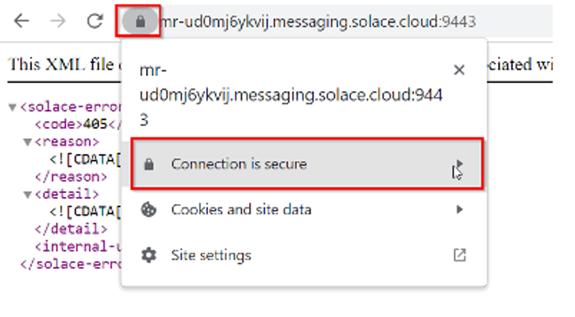

Click on Certificate is valid.

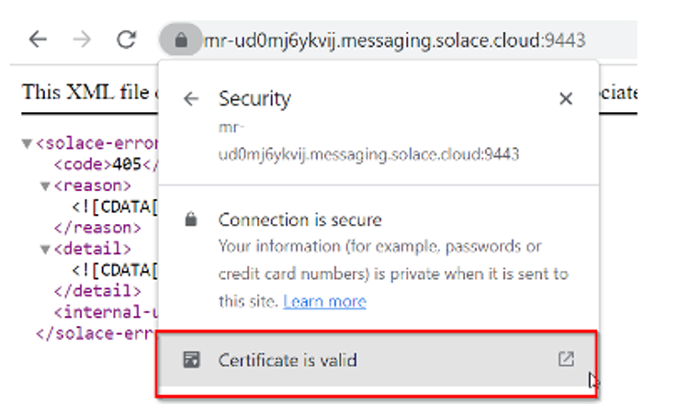

Go tothe Details tab and export the file to save it.

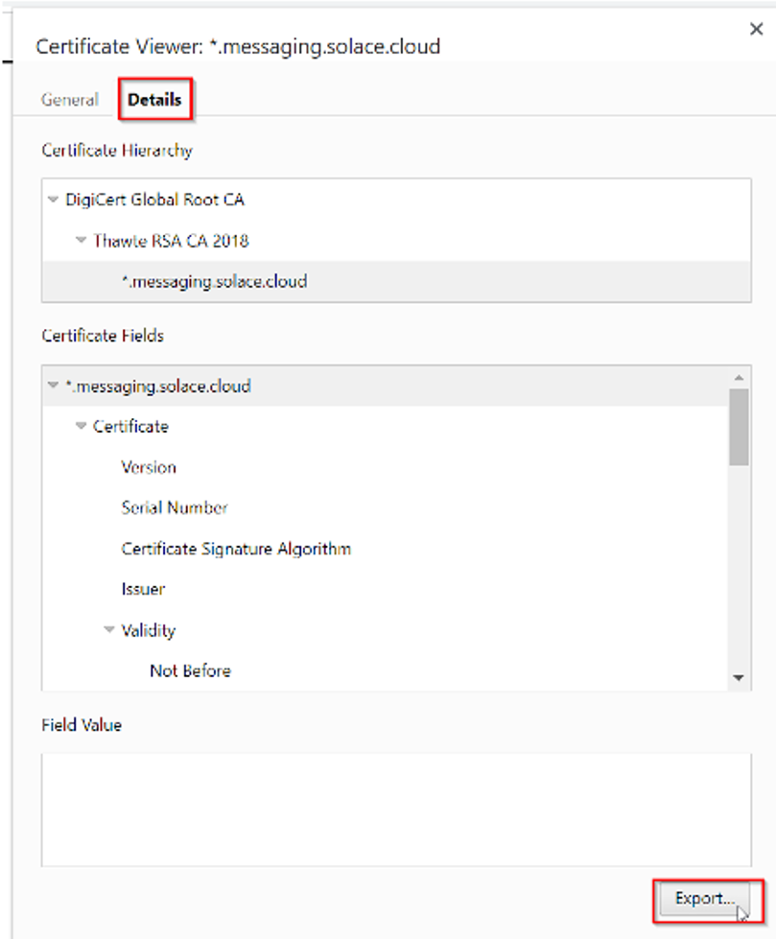

In the next step this certificate can be added to the Trust Store in SAP.

8. Add Certificates toTrust Store

* + Transaction: STRUST
  + Select Certificate List as used in RFC destination created above
  + Click button Import certificate (1)
  + Click button Add to Certificate List (2)

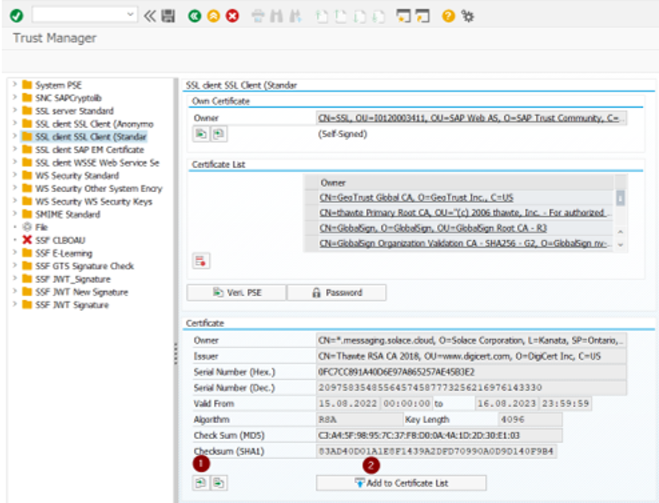

After adding the certificates, you will receive a 405 “Method not allowed” in the connection test of transaction SM59, which is correct as this means it’s reaching the ‘Advanced Event Mesh, The Asapio Integration Add-On will later build the complete URL together leading to a successful response with a 200.

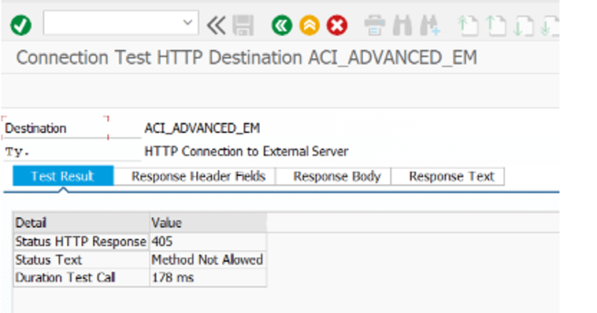

Here we can see it in transaction /n/asadev/aci_monitor which is explained later in this document.

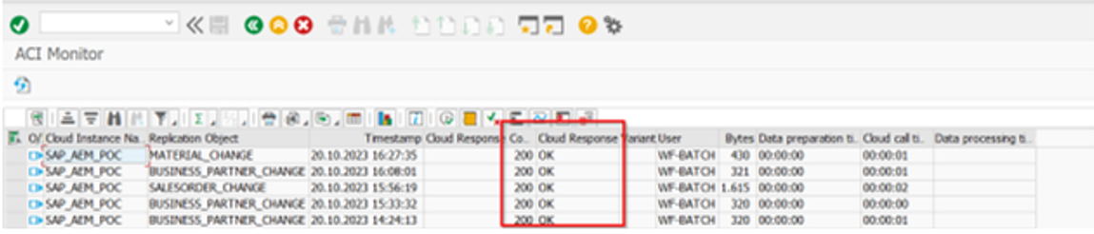

9. Add your RFC-Connections to the Asapio Integration Add-On and remove the initial RFC-Destination.

* Go to transaction SPRO >IMG >Asapio Integration Add-On >Connection and Replication Object Customizing.
* “ACI_SOLACE_DEMO_SCOTT”.
* Double-click on Instance SAP_AEM_POC and remove RFC-Destination
* Now add your new created RFC-Destination.

Before:

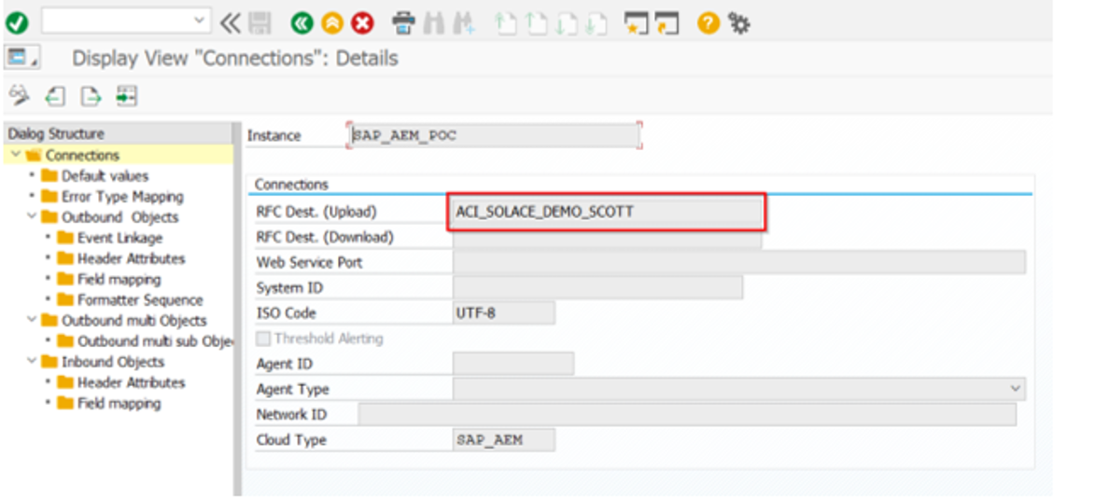

After:

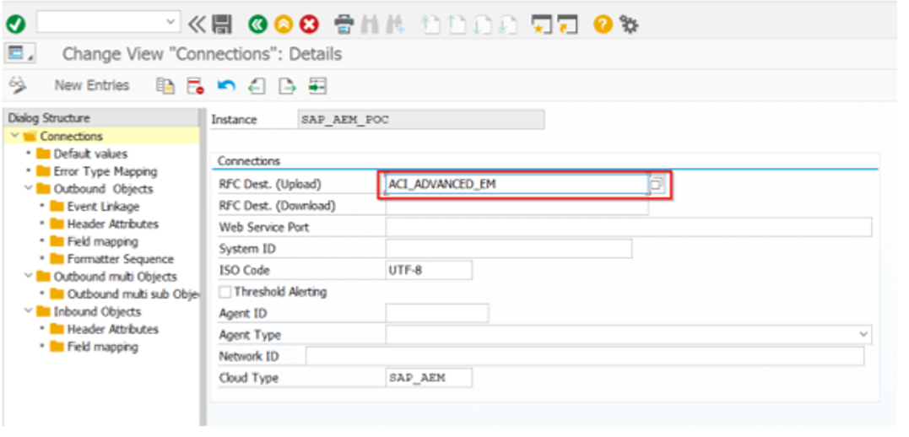With these steps prepared, we are all set to send messages to AEM. If you have any questions or require further assistance, please feel free to reach out to us. We look forward to a successful workshop!

10.Trigger and test an event

* Go to transaction BP
* Change Business Partner
* Save

After saving the event will be created and the JSON sent to Solace.

* Goto transaction /n/asadev/aci_monitor
* You will be able tosee the event and the message that was sent to AEM

To see the sent data select the tab “Traces”.

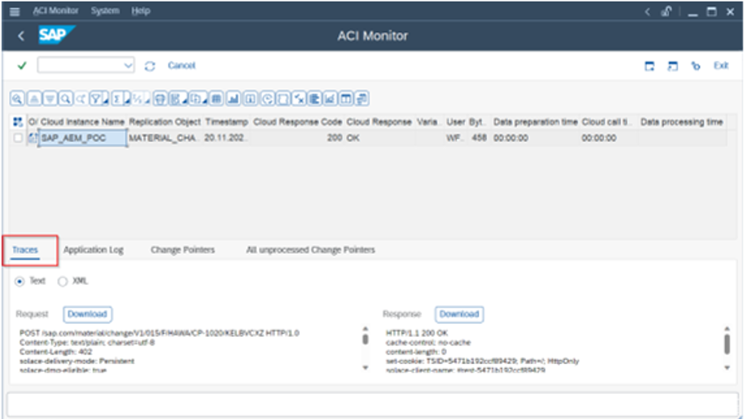

**Configuration Details**

With the import of thetransport including the predefined content youwill have the following

outbound objects in your system:

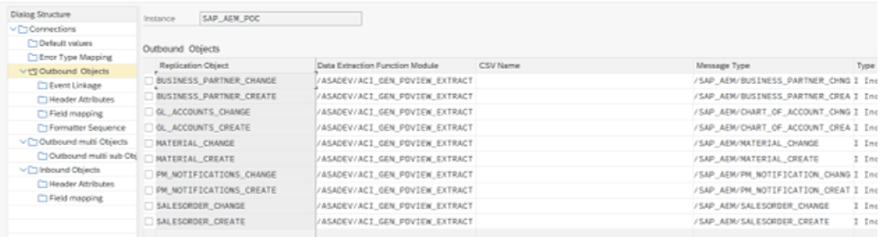

Business Partner

BUSINESS_PARTNER_CREATE

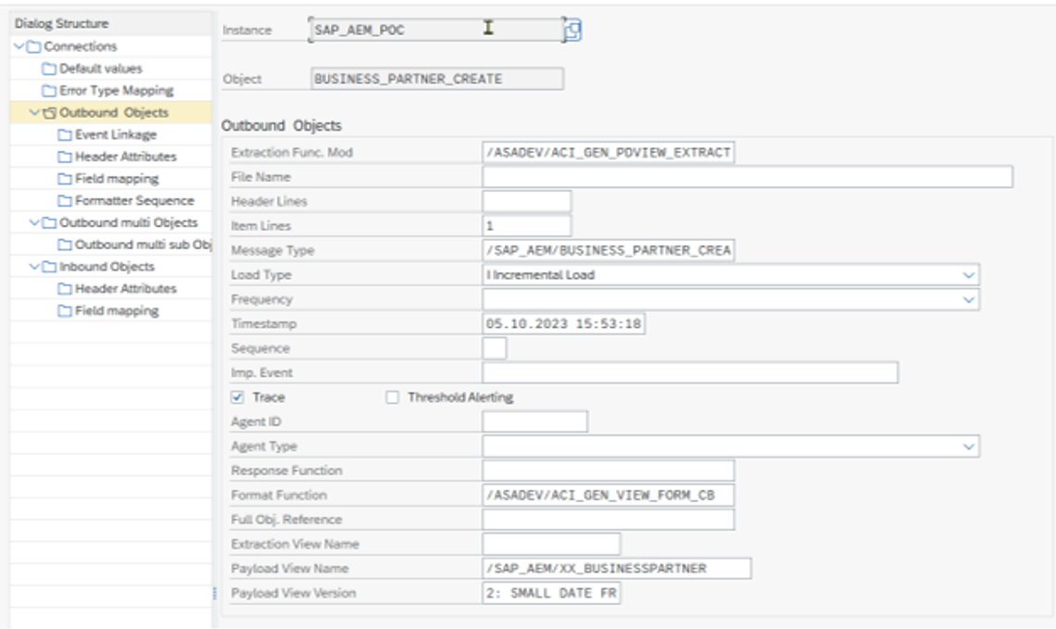

Event Linkage:

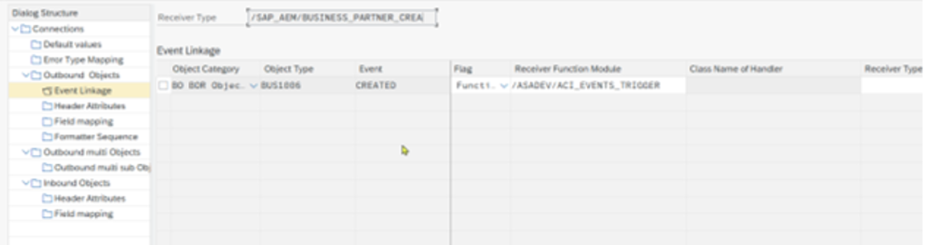

Header Attributes:

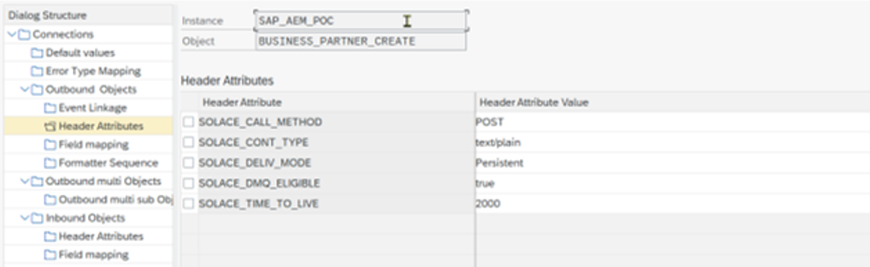

Field mapping (i.e. dynamic topic configuration)

